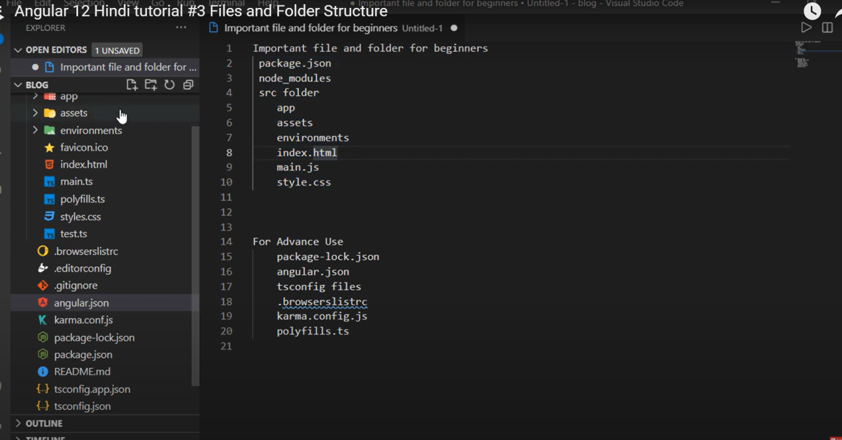

* package.json – all dependency is here here
* node_module -all library is installed here
* src folder- developer done it’s 90% work here
* in src folder we have first app folder (app folder is basically a component)
* Component: A peace of code that we can re-use
* First file load in angular is index.html then main.ts
* Package.loc.json( it keeps detail of all dependency similar to package.json , but here detail description of dependency)
* Tsconfig (here we have configuration regarding typescript and strict like condition manage(global configuration))
* Tsconfig.app (here we have app lavel configuration )
* Polyfills.ts( here we add some library that support our browser)

**Interpolation**

Interpolation is use for displaying dynamic data on html page.

* Assignment operator not work in interpolation
* Increment and decrement operator also not work here
* Type of not work here

**Component**

* Component is use for create specific functionality, it contain 4 file , template file , style , ts, specsts file.
* We can create inline style and inline template component, syntax is mentioned on bellow screenshot.

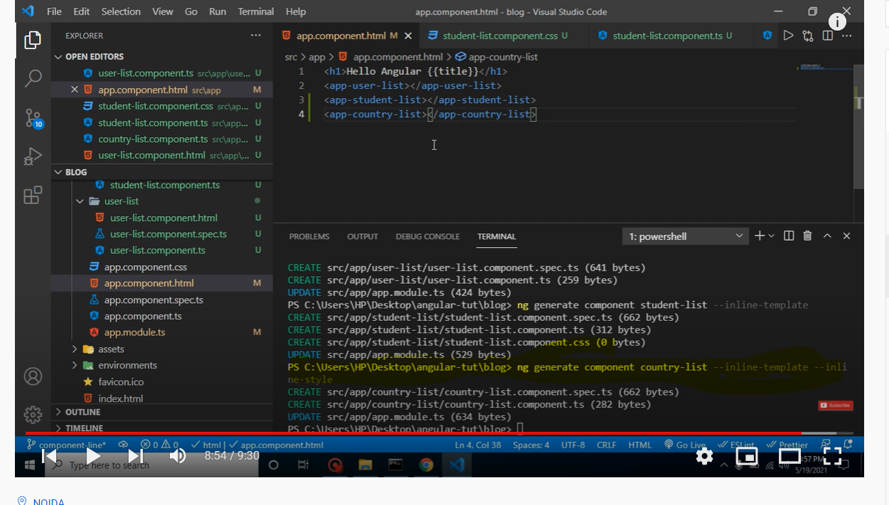

**Module**

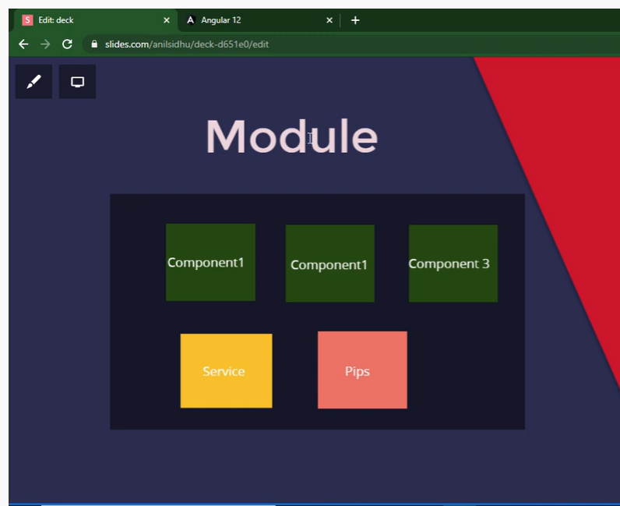

We can say Module Is ia a complete feature. In which include component, service, pipes

* If we create a module then we need to register that module in root module in import section and all component of that module will add or register in new module not in root module and if we want to access any component that create in new module then in app component we need to import.

**Function calling**

* In function we need to declare data type of the variable in angular -12 , it is because in typescript now strict mode true. In 9 , 10, 11 strict mode was false.
* Get the dynamic value from html to function below is the screenshot. We need to give id and then that id.Value



* If we want to get the value of the property then we can gate like mention in below screenshot

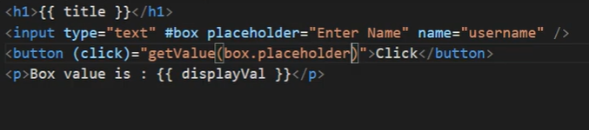

* Input box value we can get multiple way, one is two way binding

**Property binding**

* If we are checking Boolean value then in place of interpolation we need to select property binding

**If and Else condtion**

<p *ngIf= "show; then dispifcondition else elseblock" >rajeev </p>

<ng-template #dispifcondition>

<h2>if condtiona scuess</h2>

</ng-template>

<ng-template #elseblock>

<h2>else condtiona scuess</h2>

</ng-template>

* In place of else if we use mentioned syntax in below screenshot in angular

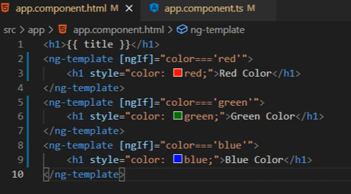

**Switch statement**

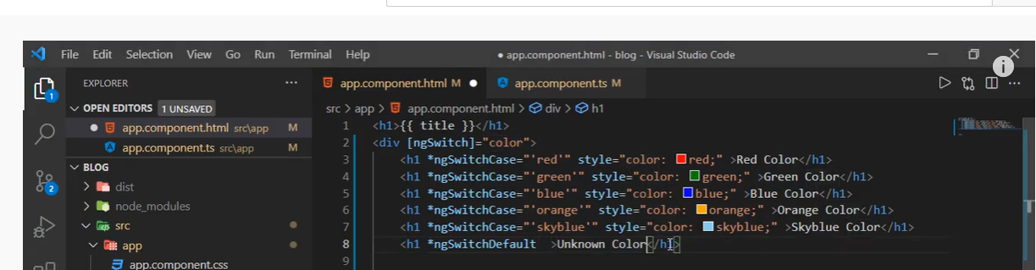

**Nested for loop**

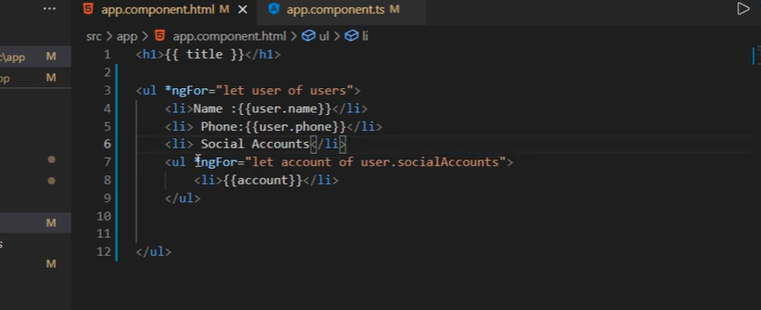

**Style binding:**

* Dynamic style binding( variable come from ts file )

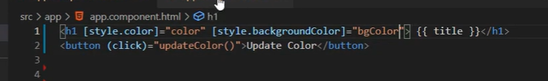

**Template form example**

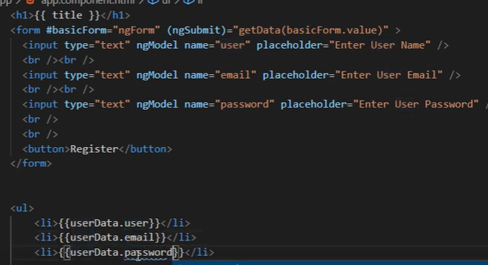

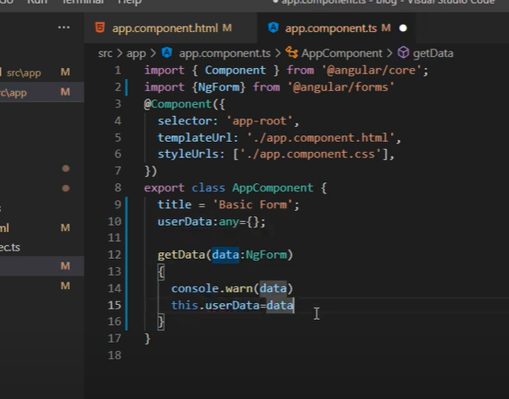

**To create todo list below is the screenshot for .ts and html file respectively**

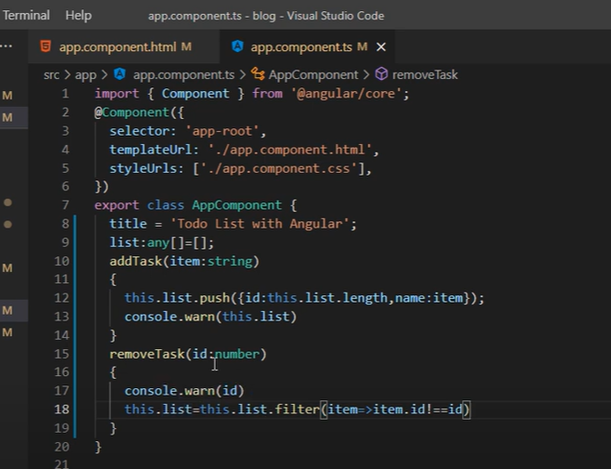

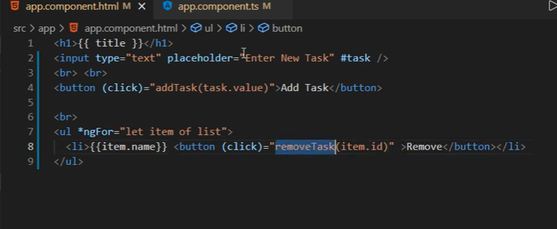

Pass Data child to component

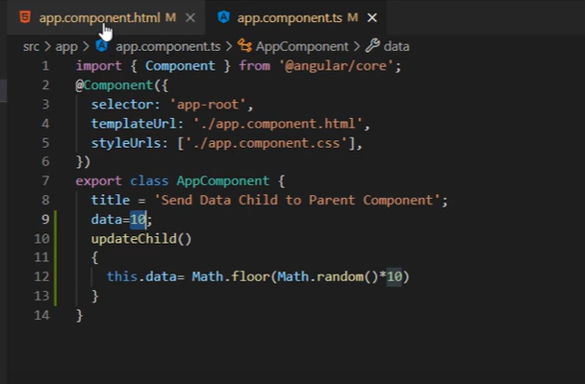

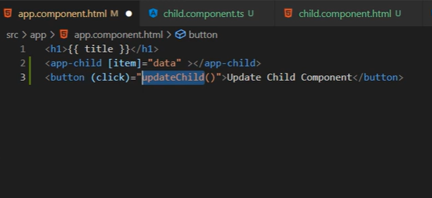

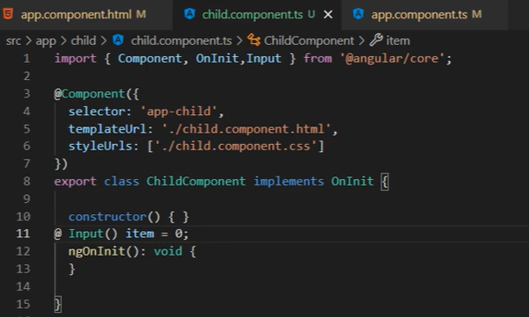

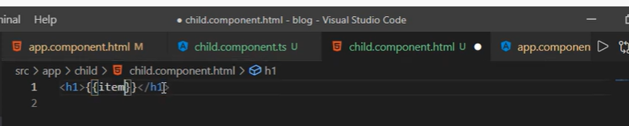

# Reusable Component Task

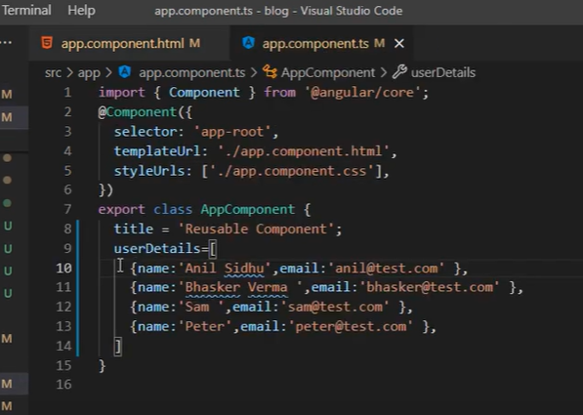

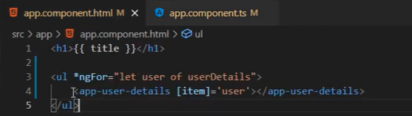

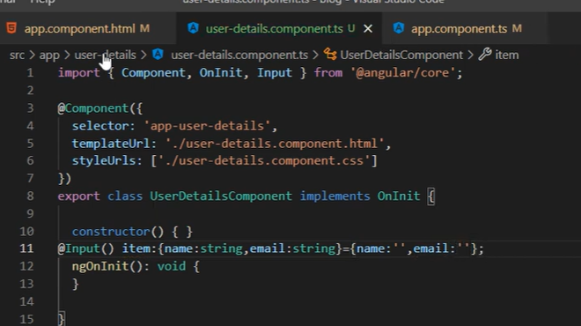

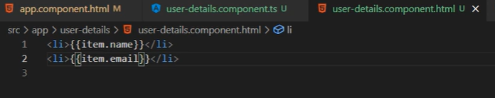

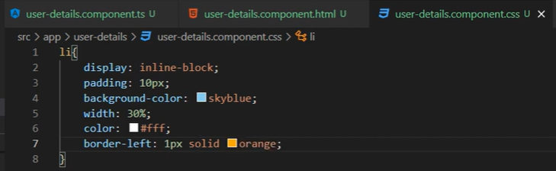

# Send data child to parent component

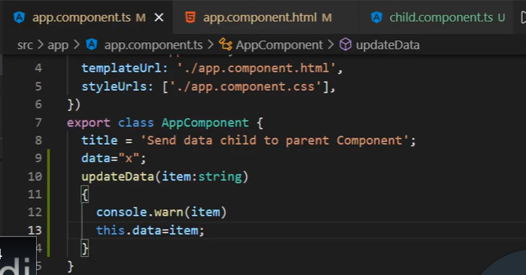

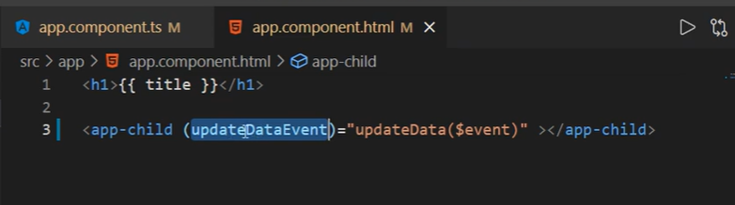

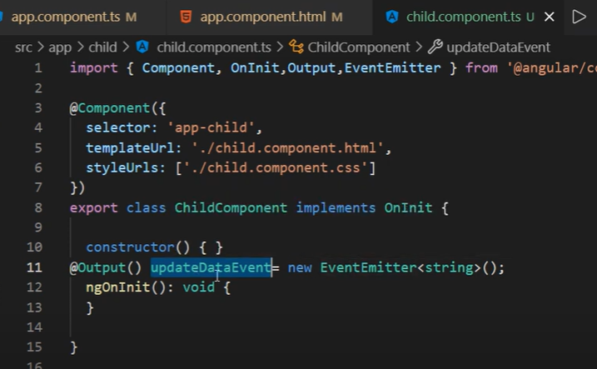

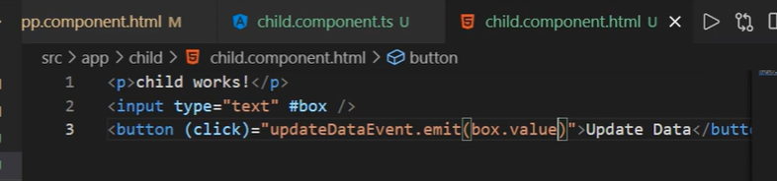

* Child to parent data send only with function.

# Two way binding

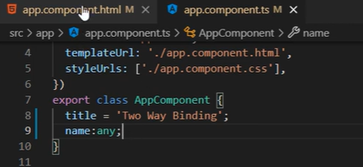

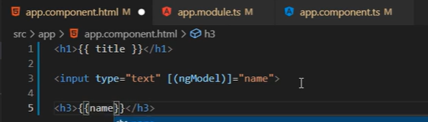

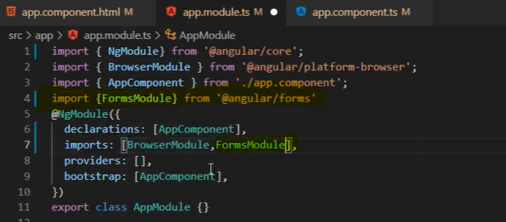

# Template Reference Variable

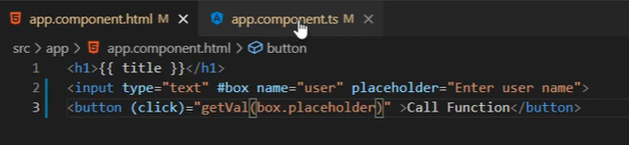

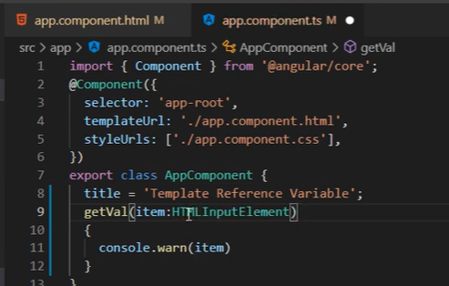

**Note:** in above screenshot HTMLInputElement is a type for input element, It is not mandatory we can take here any type also but for best practice please use HTMLInputElement

# Basic typescript for angular

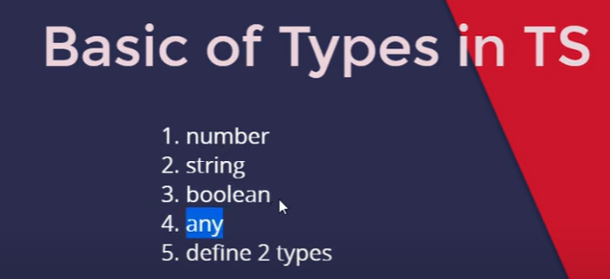

# Basic of Pipes in angular

* Transform data to one form to another form like eg. Date
* Pipe is use in html page not in ts page.

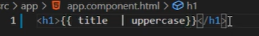

# Advance Pipes

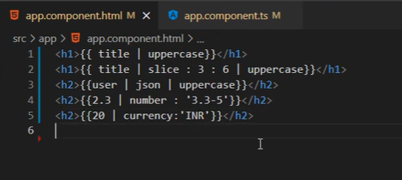

# Make custom pipes

* ng g p <pipe name>

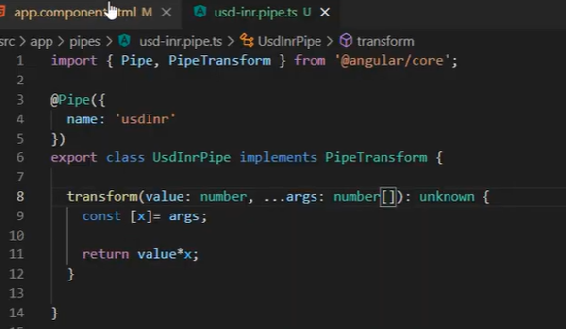

Custom pipe eg.

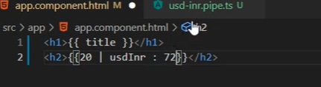

# Form introduction

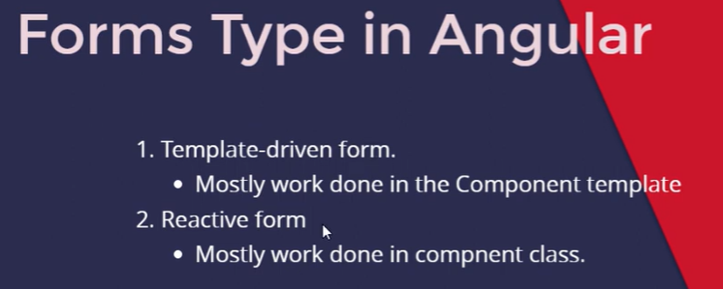

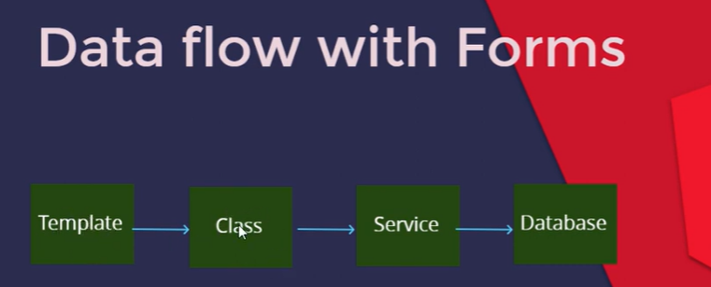

# Template driven form

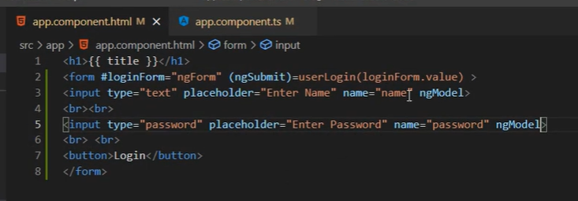

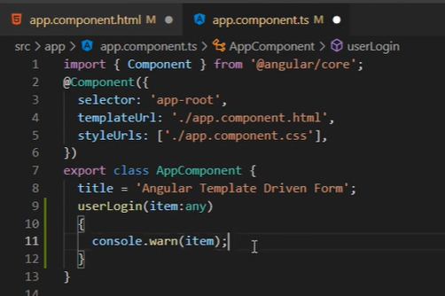

* in template driven field we need name field otherwise it show error.

# Template driven form Validations

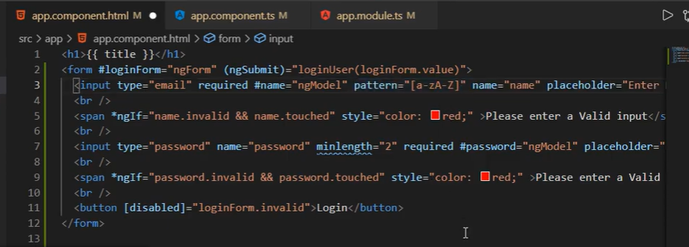

# Reactive Form in Angular

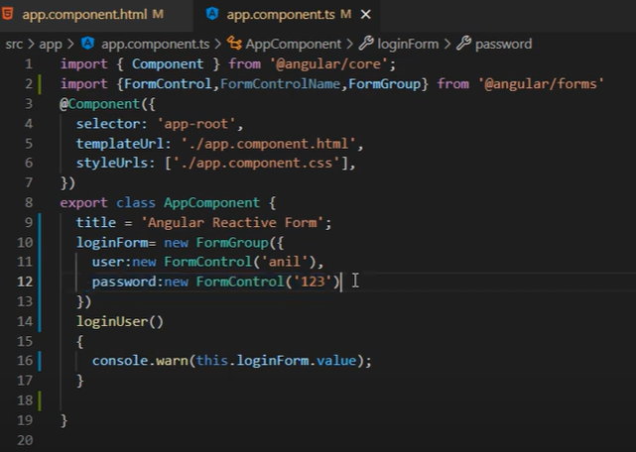

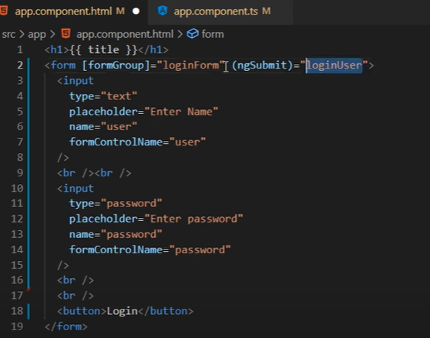

# Reactive form Validations

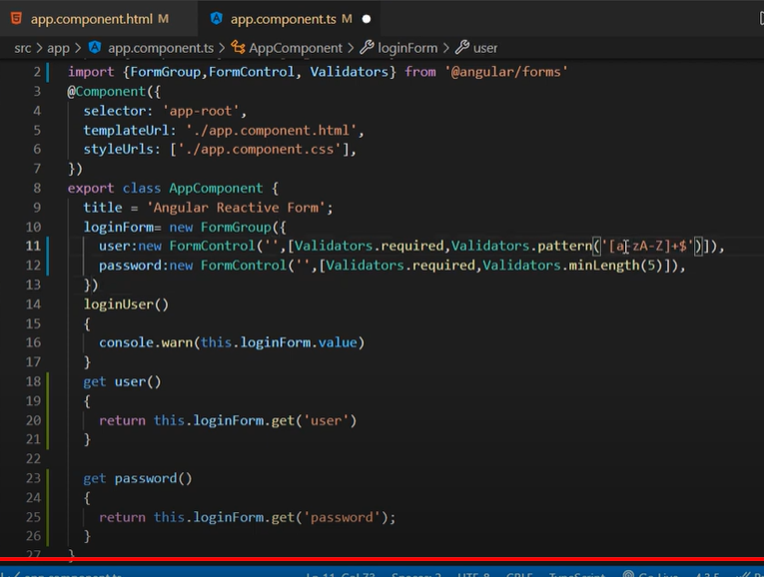

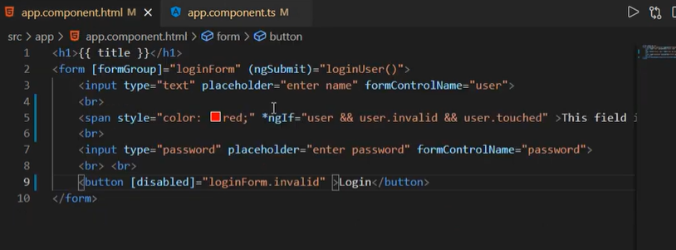

# Directives | custom | example

* It provide addition feature to html element
* ng g directive <directive name>

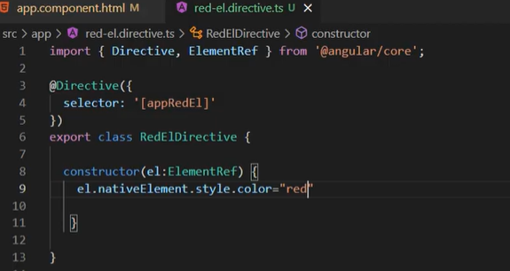

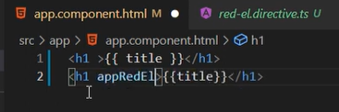

# Basic Routing

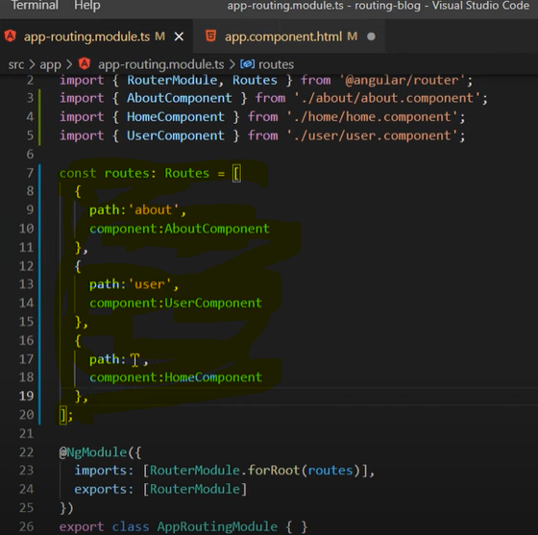

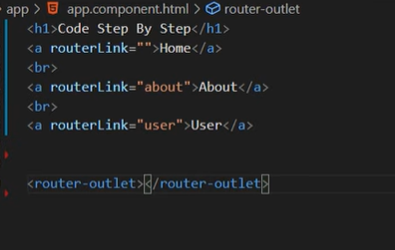

# Dynamic Routing in angular

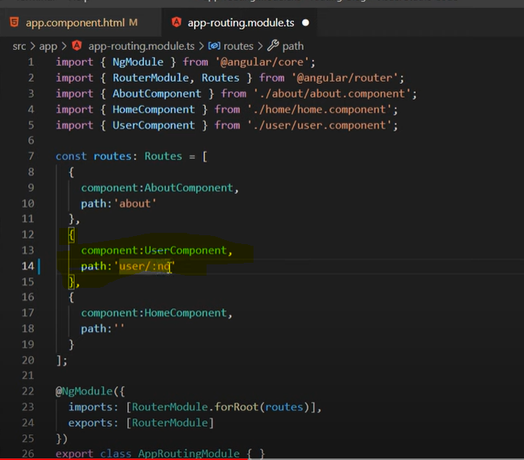

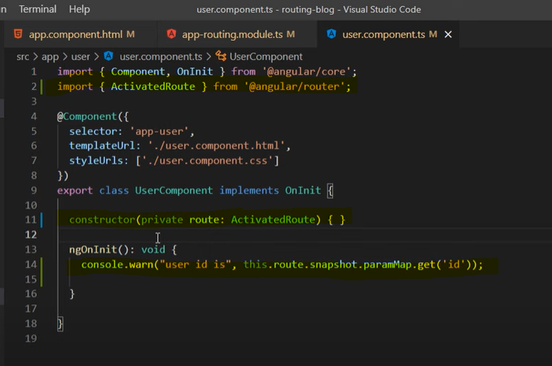

# Wild Card | 404 page routing

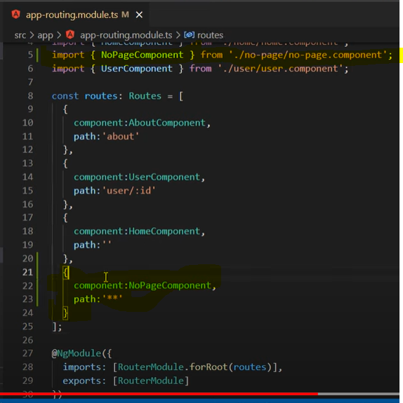

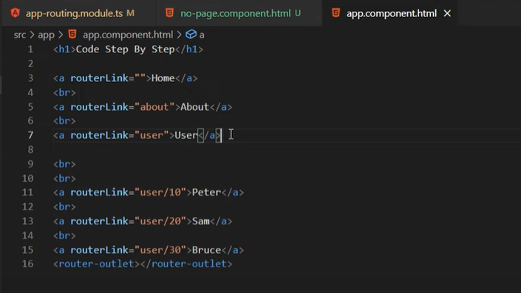

# Child Routing

* page inside the page called page

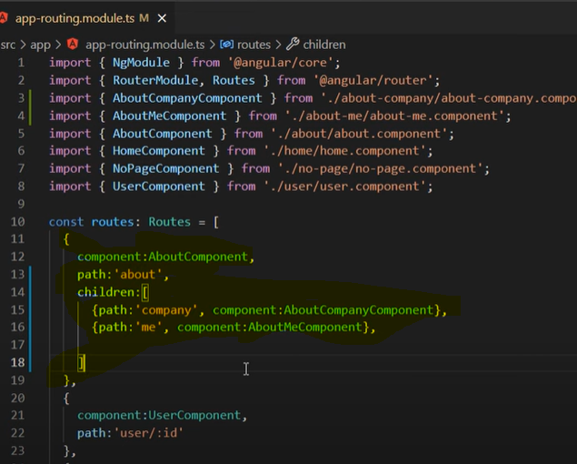

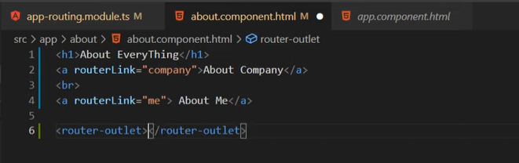

# Make service and use in multiple files

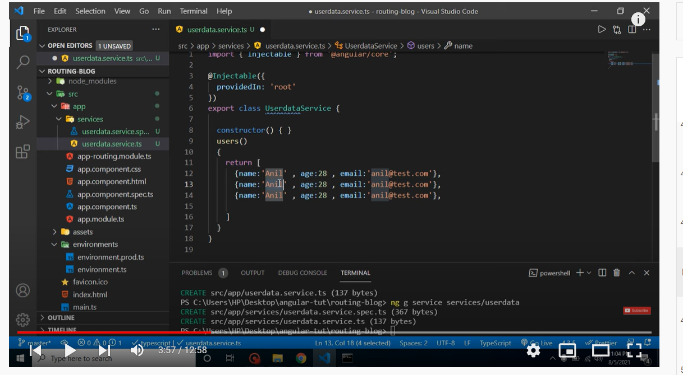

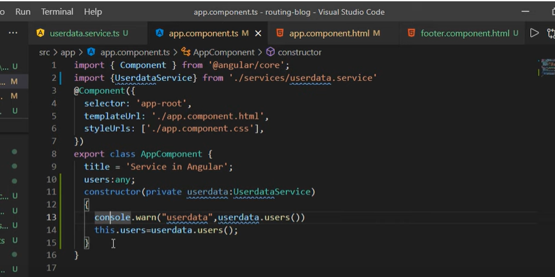

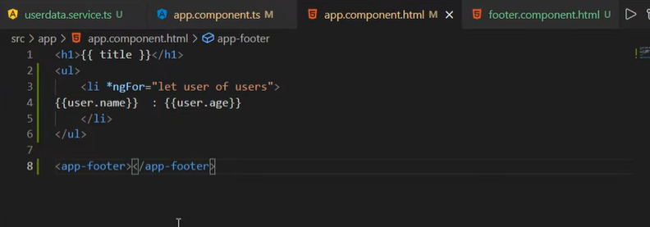

# get data from API and display

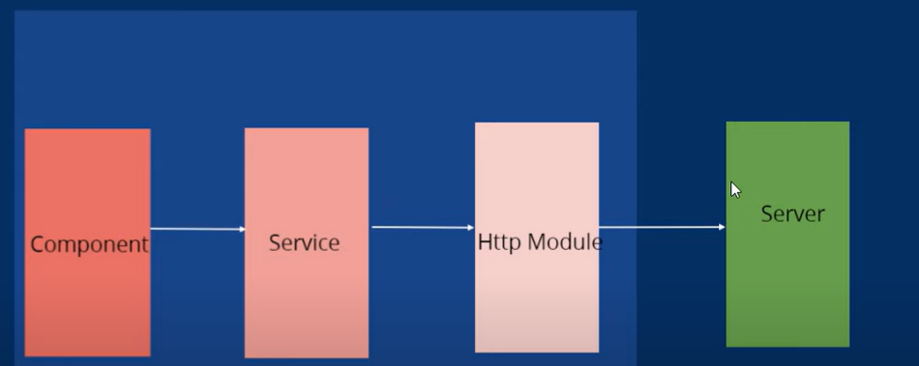

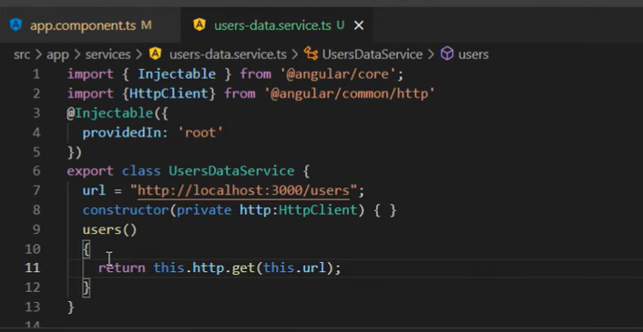

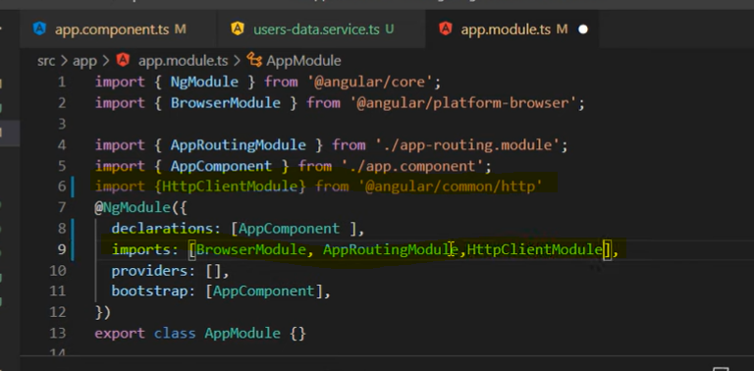

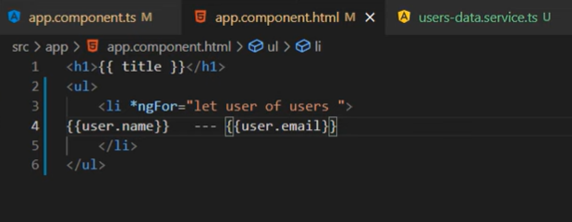

# save data with API

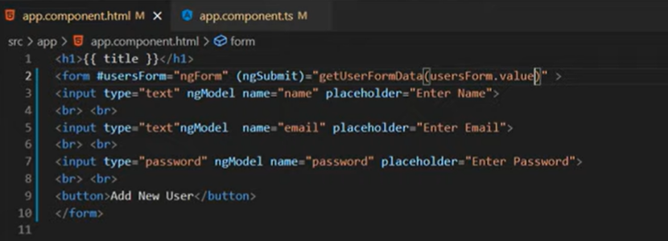

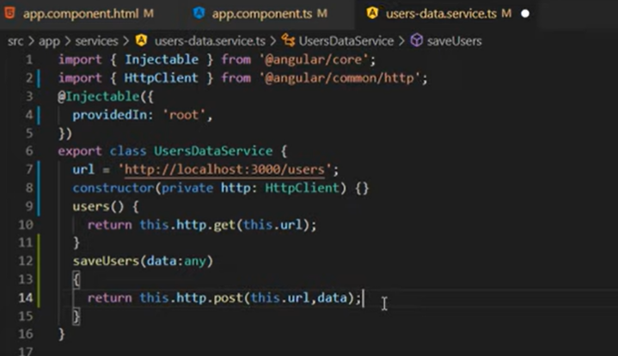

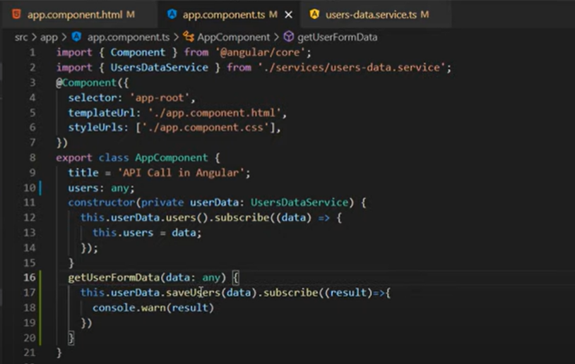

# Model and Interface

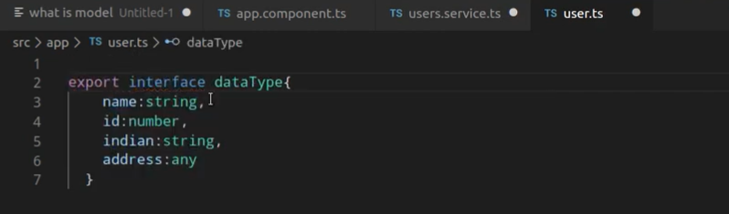

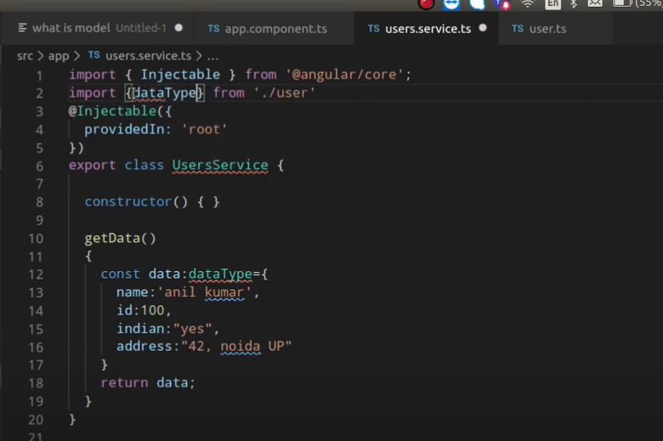

# Recap Module and Routing

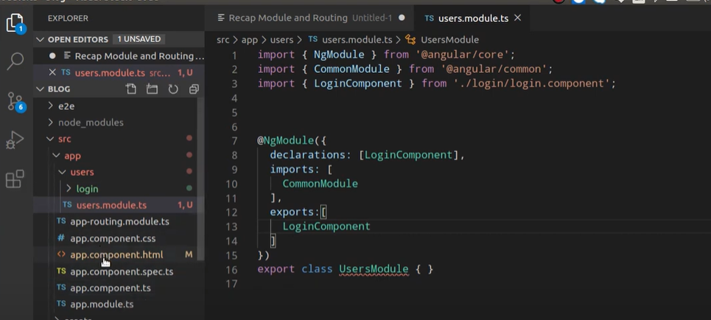

* separate module file for Users component

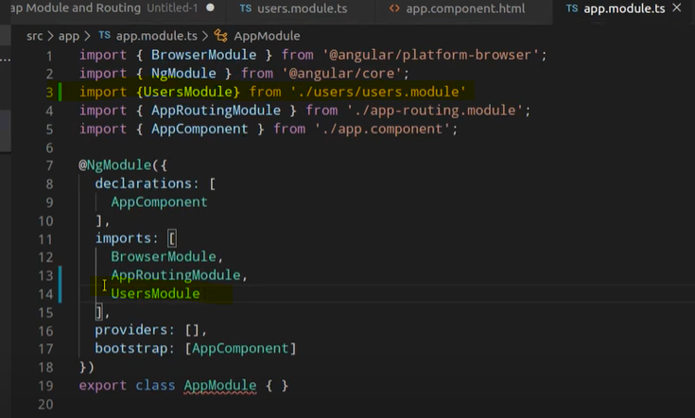

# Routing Module

* separate routing module for a module and it’s components

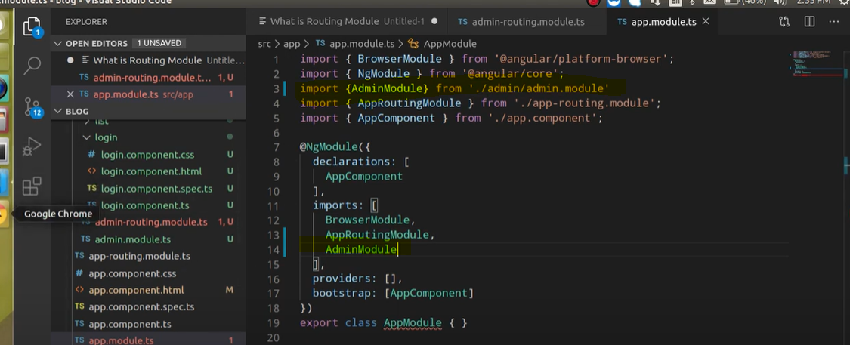

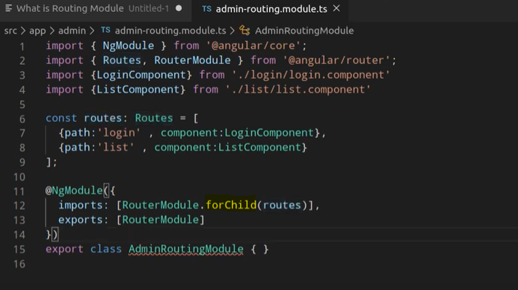

* child routing module will same like root module but it will be for a separate module like auth module. But child module have forChild highlighted in above screenshot.

# Group Routing

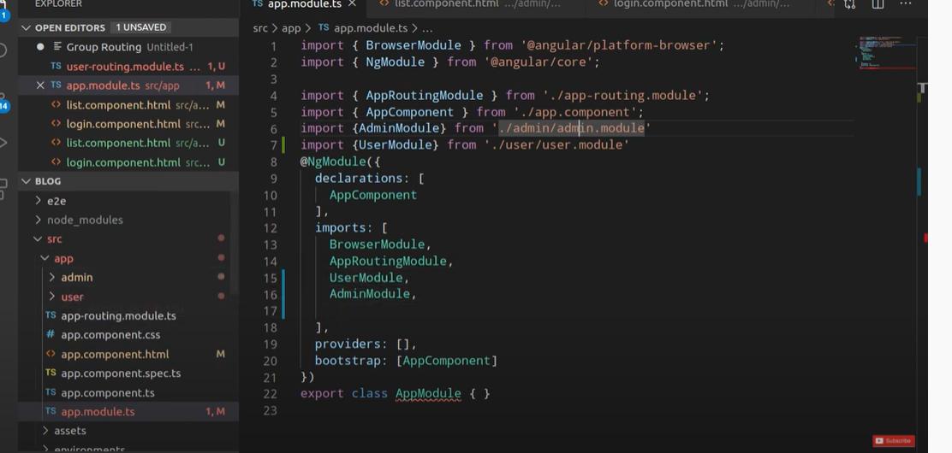

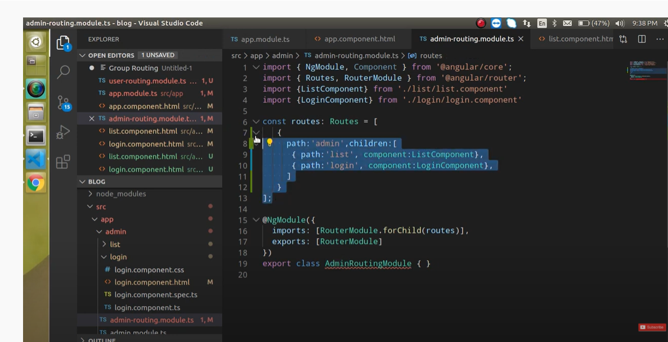

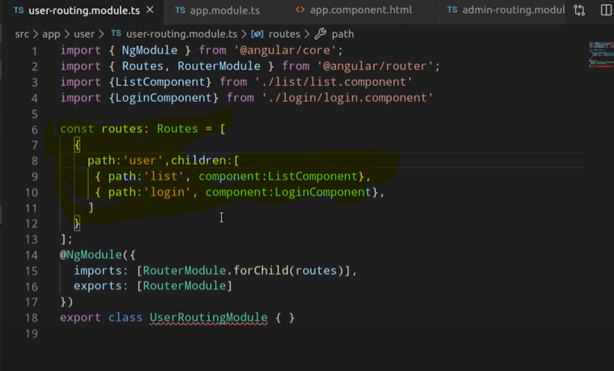

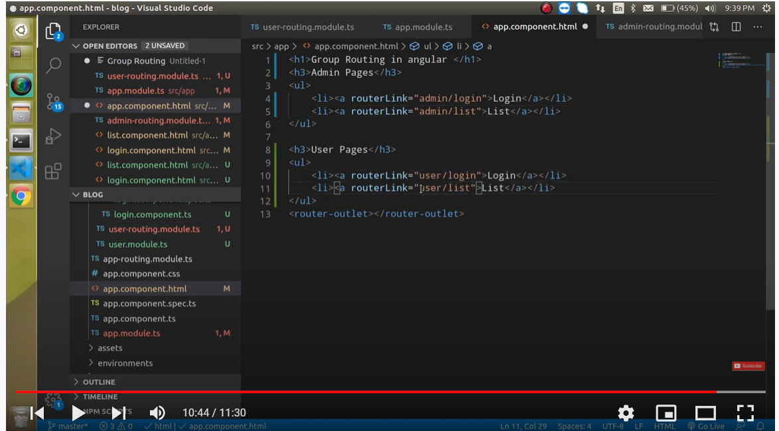

# Lazy Loading

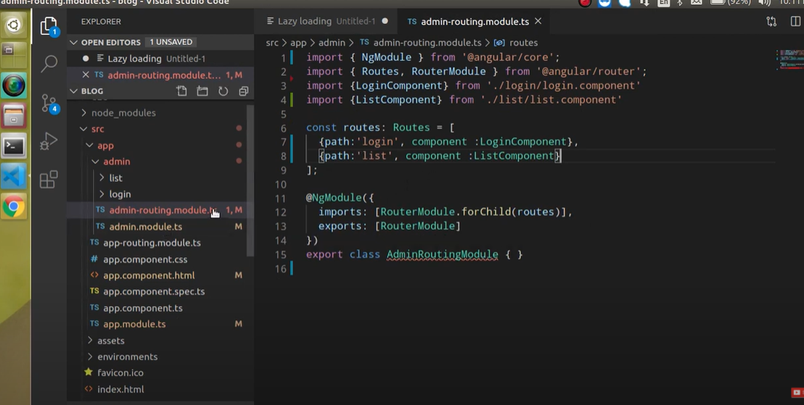

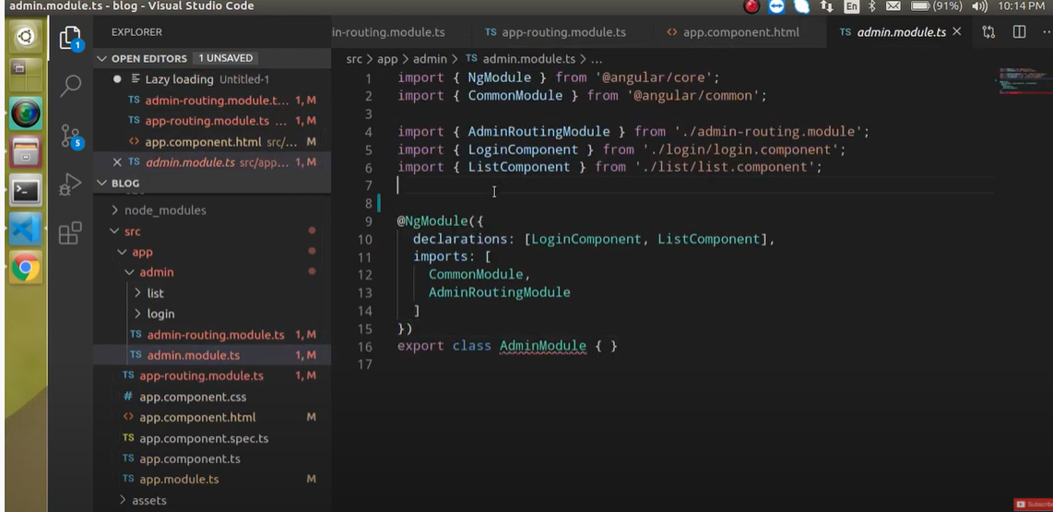

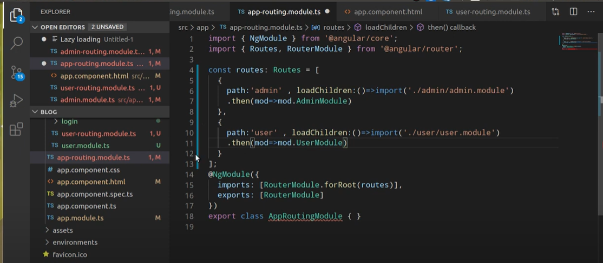

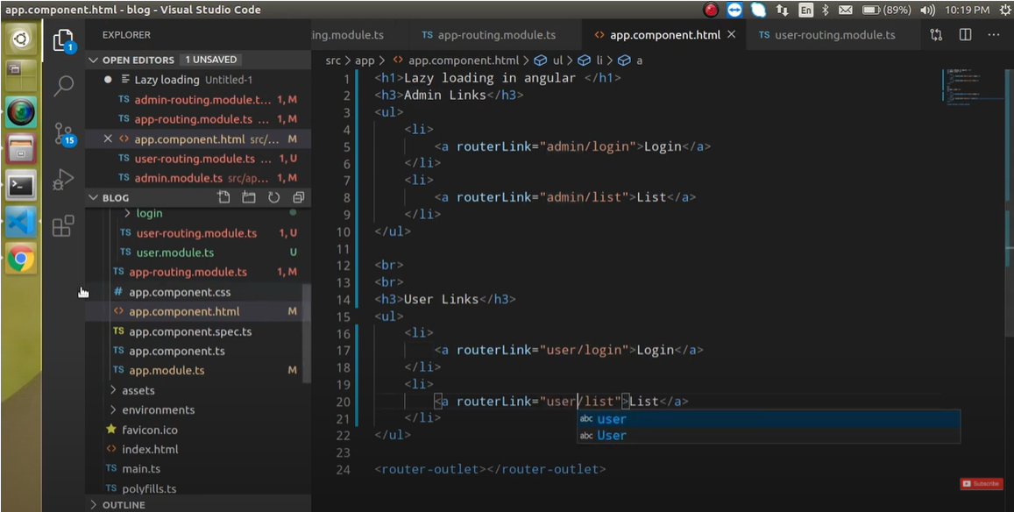

# Lazy Loading component

* This feature come in angular 9

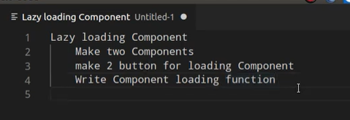

* **ViewContainerRef** (load the component in container)

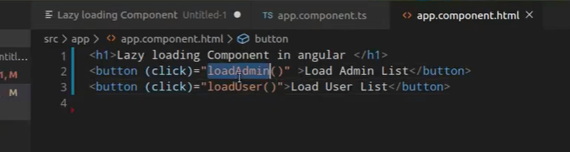

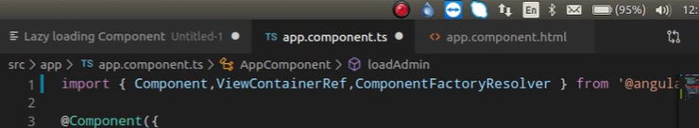

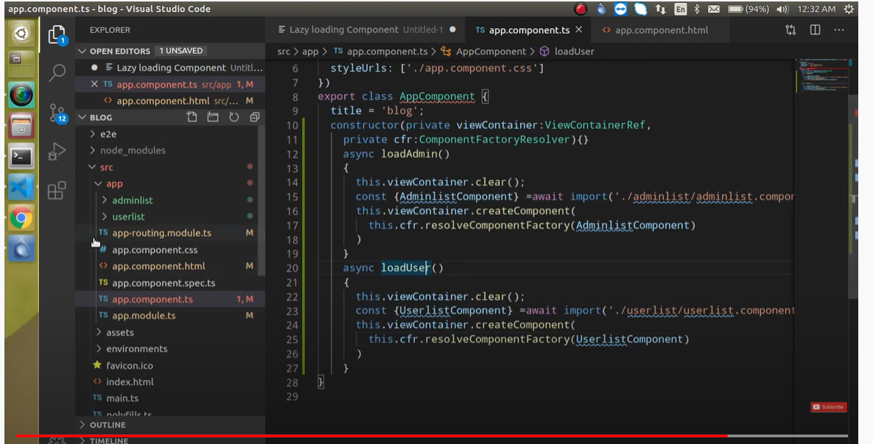

# automation Testing | Unit Testing

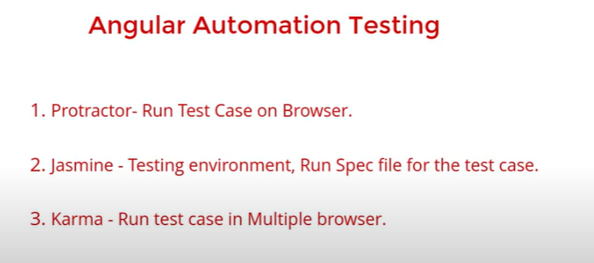

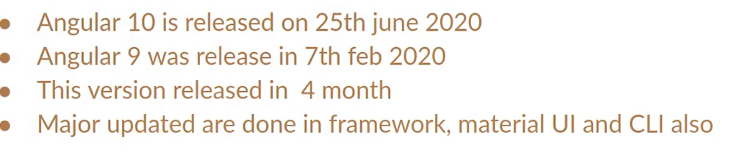



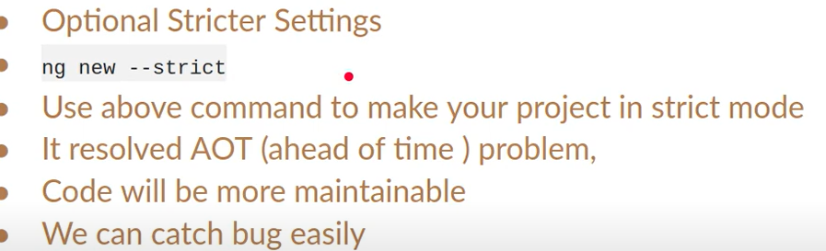

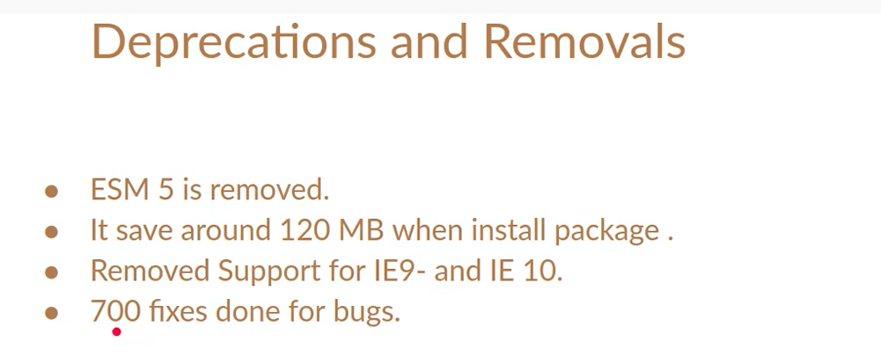

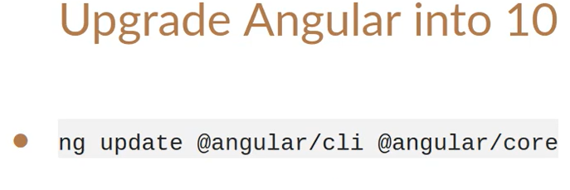

# New feature of angular 11

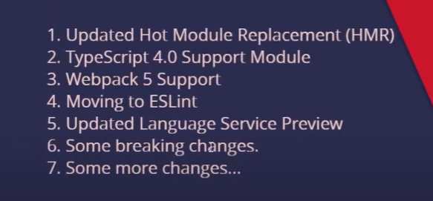

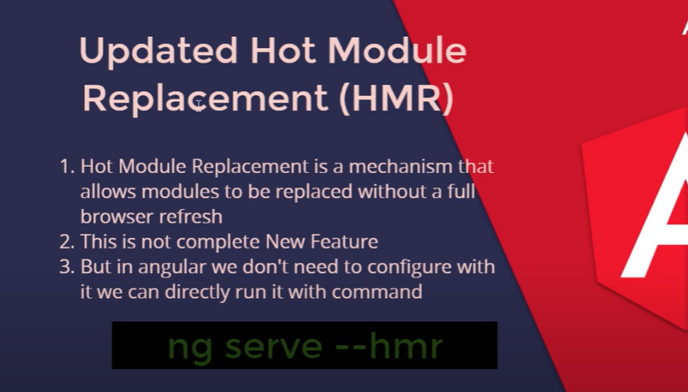

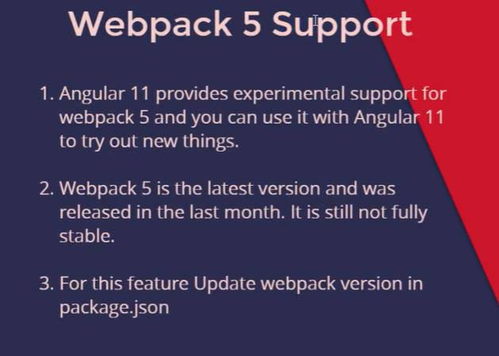

Angular 12 (new feature)

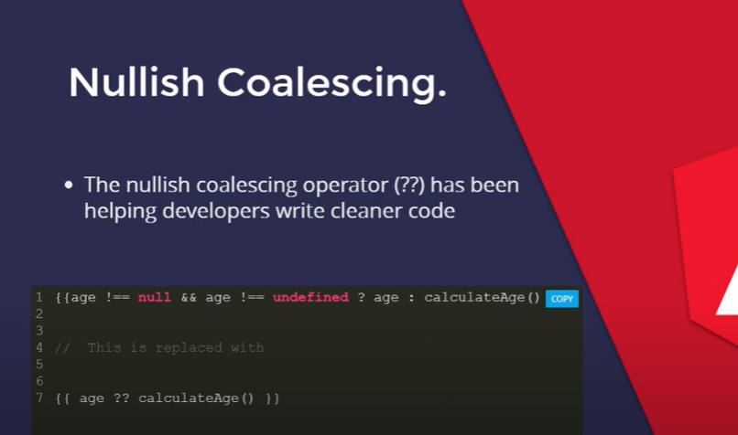

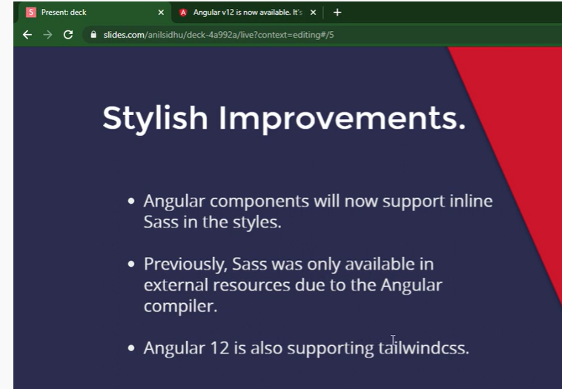

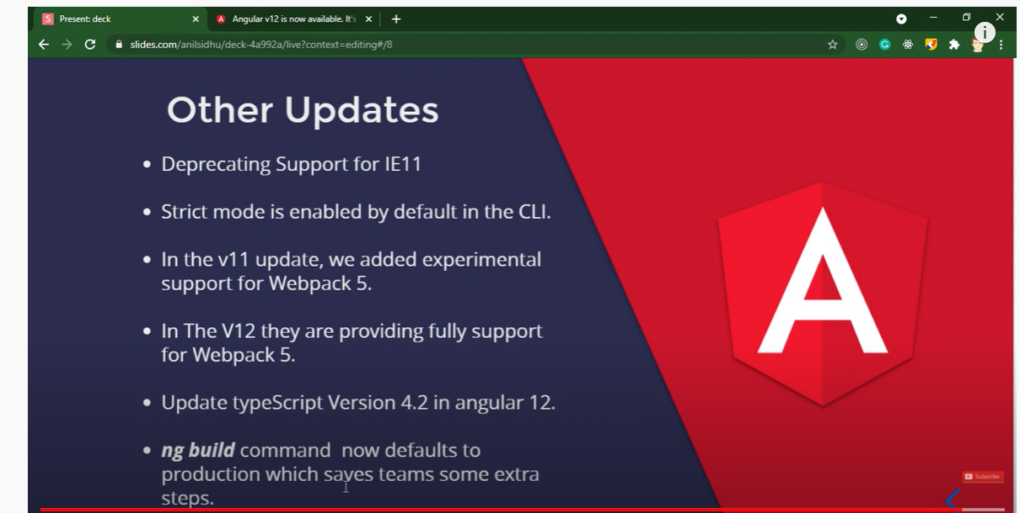

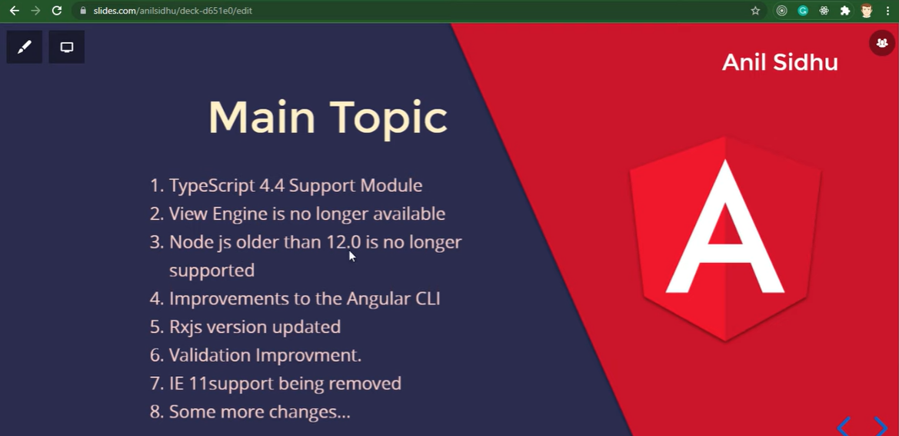

# Observables

* This is not a native function of angular. It’s com from external library name is rxjs.

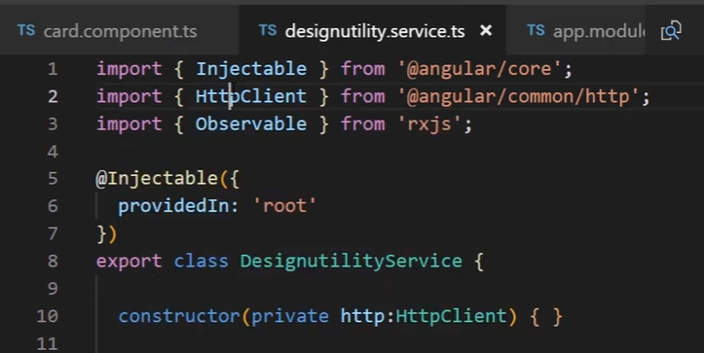

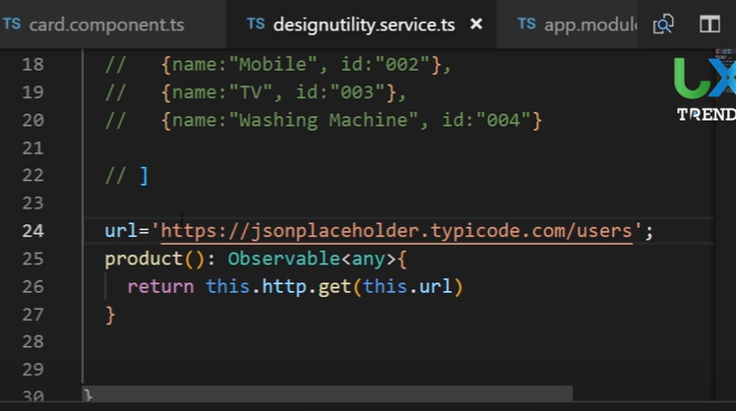

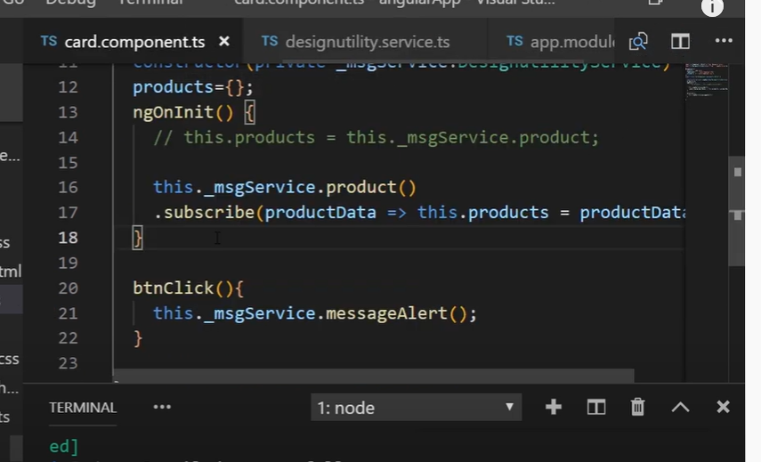

# Subject

* This is rxjs feature same like observable

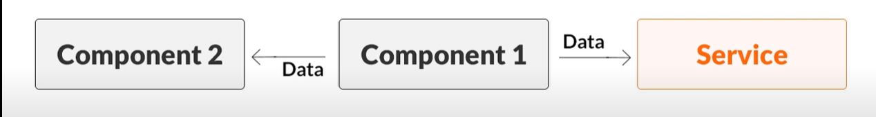

* With the help of @input and @output **decorator we can send only in parent and child but with subject we can send to any component.**

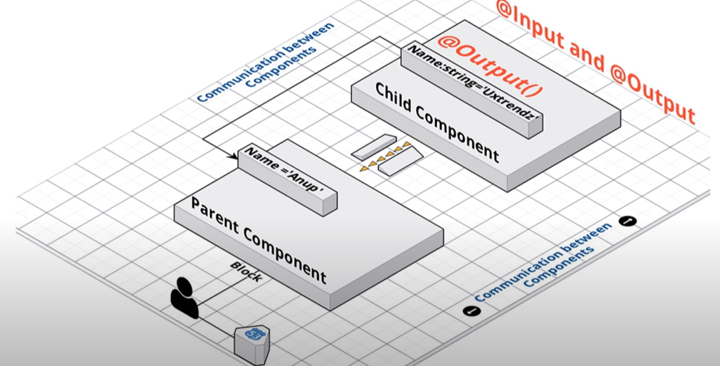

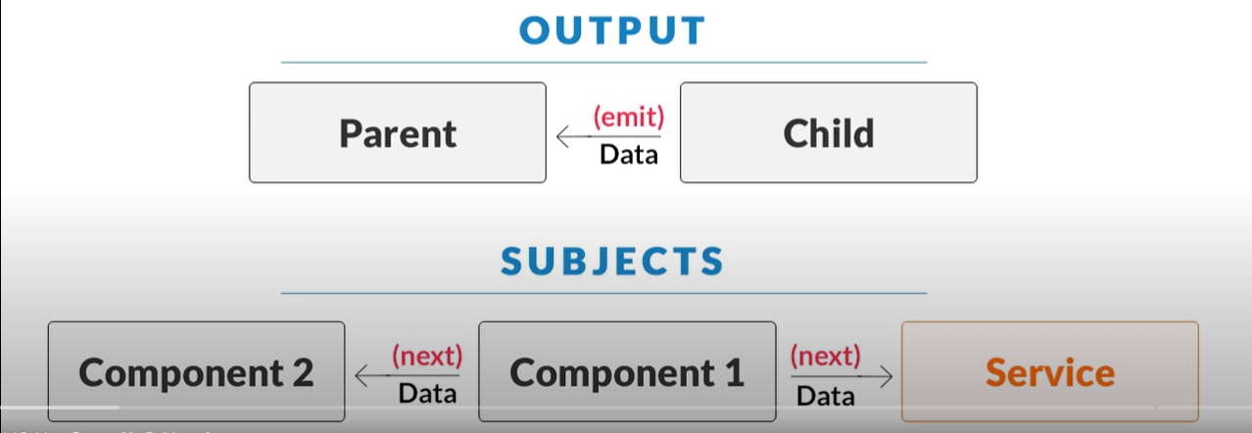

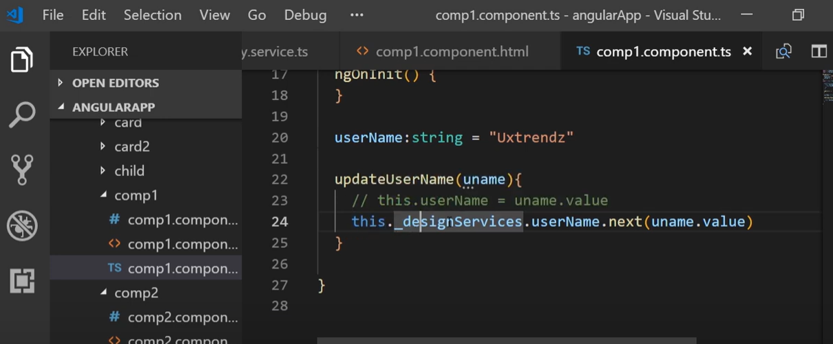

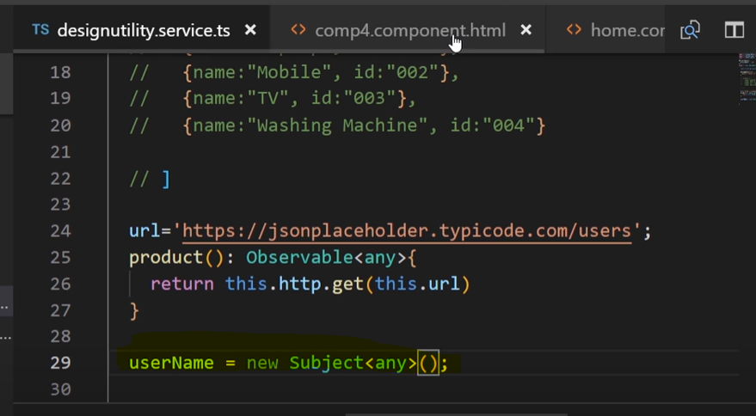

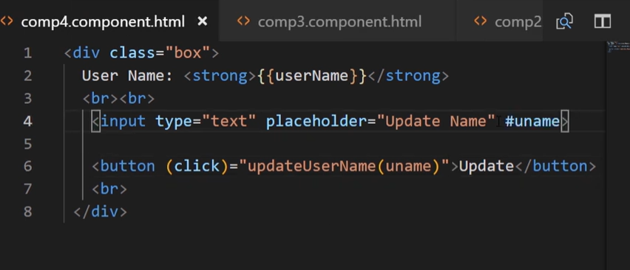

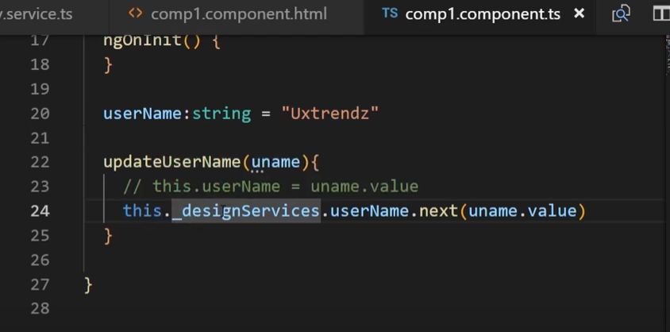

Above example of subject.

* We have to create 4 component then we need to create a service file where we need to import subject from rxjs.
* There create a username property where we need to assign the value from the component so that in every component we can show same name.
* 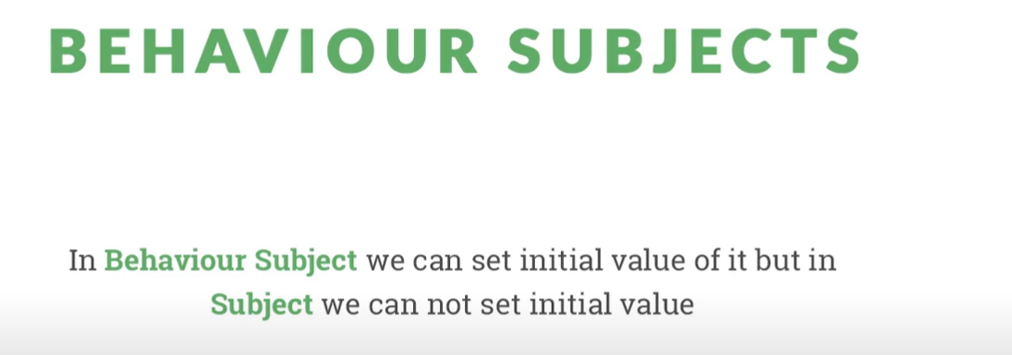

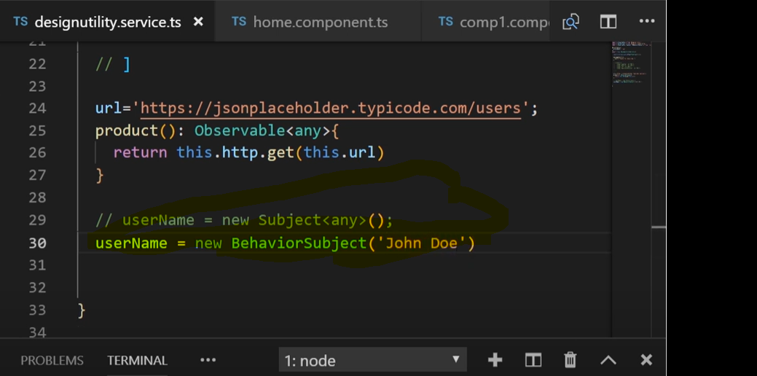

# Component Lifecycle Hooks in Angular

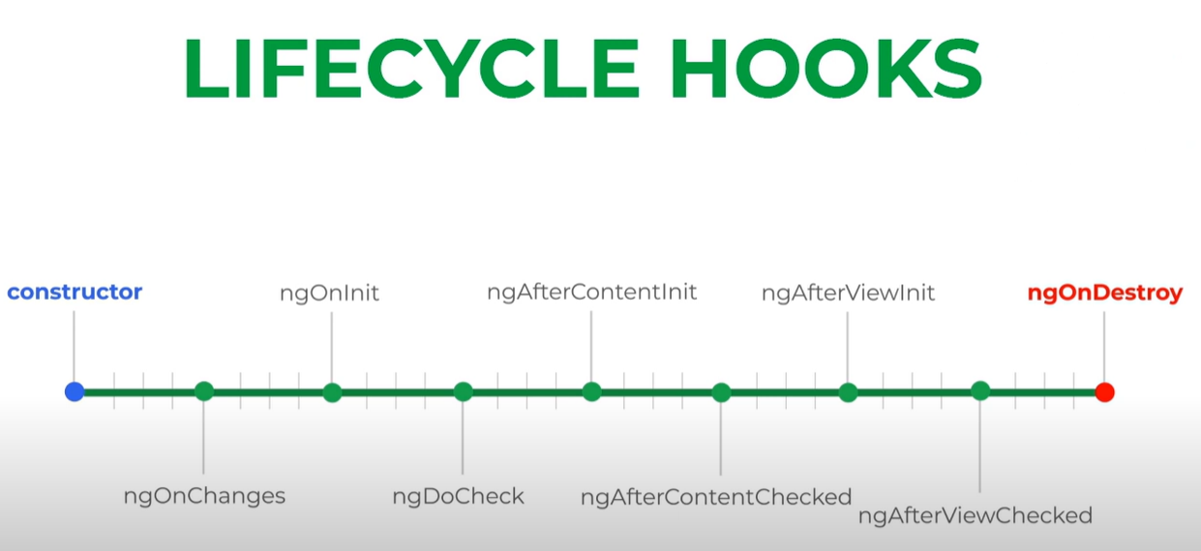

**ngOnChanges()**

Respond when Angular sets or resets data-bound input properties. The method receives a [SimpleChanges](https://angular.io/api/core/SimpleChanges) object of current and previous property values.

Called before ngOnInit() (if the component has bound inputs) and whenever one or more data-bound input properties change.

Note that if your component has no inputs or you use it without providing any inputs, the framework will not call ngOnChanges().

Note that this happens very frequently, so any operation you perform here impacts performance significantly

**ngOnInit()**  
Initialize the directive or component after Angular first displays the data-bound properties and sets the directive or component's input properties.

Called once, after the first ngOnChanges(). ngOnInit() is still called even when ngOnChanges() is not (which is the case when there are no template-bound inputs).

**ngDoCheck()**

Detect and act upon changes that Angular can't or won't detect on its own.

Called immediately after ngOnChanges() on every change detection run, and immediately after ngOnInit() on the first run

**ngAfterContentInit()**

Respond after Angular projects external content into the component's view, or into the view that a directive is in.

Called once after the first ngDoCheck()

**ngAfterContentChecked()**

Respond after Angular checks the content projected into the directive or component.

Called after ngAfterContentInit() and every subsequent ngDoCheck().

**ngAfterViewInit()**

Respond after Angular initializes the component's views and child views, or the view that contains the directive.

Called once after the first ngAfterContentChecked()

**ngAfterViewChecked()**

Respond after Angular checks the component's views and child views, or the view that contains the directive

ngAfterViewInit() and every subsequent ngAfterContentChecked().

**ngOnDestroy()**

Cleanup just before Angular destroys the directive or component. Unsubscribe Observables and detach event handlers to avoid memory leaks.

Called immediately before Angular destroys the directive or component.

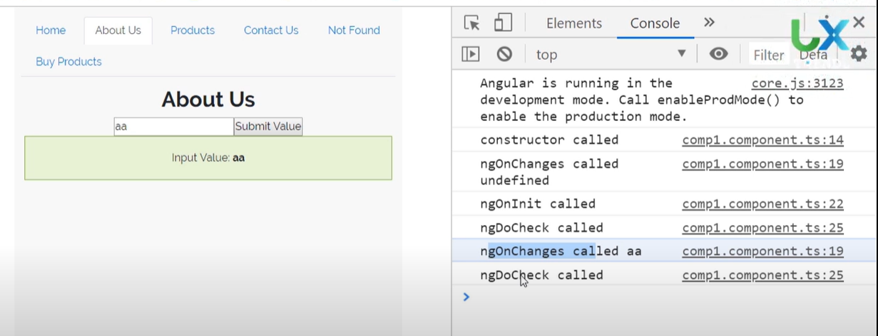

# ViewChild()

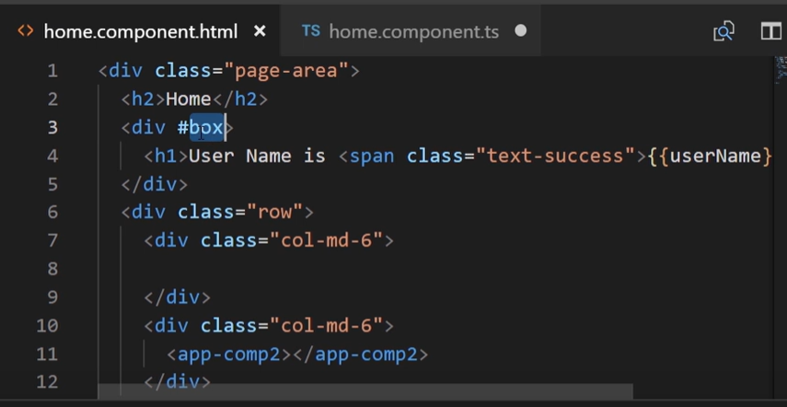

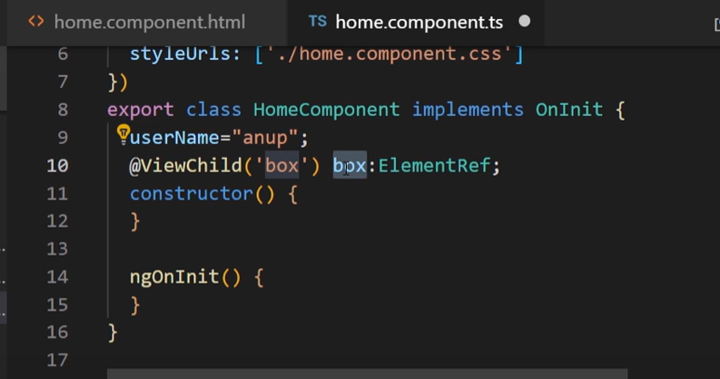

* We need to use view child in ngA**fterViewInit()** hook so that all view loded.

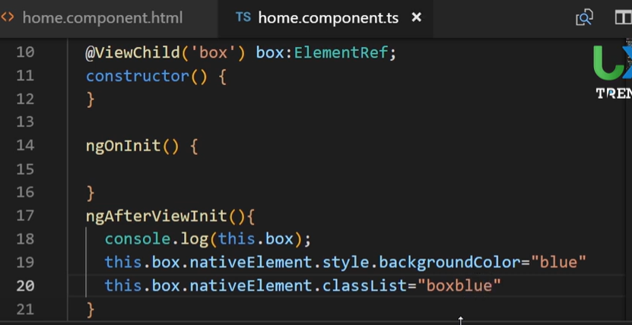

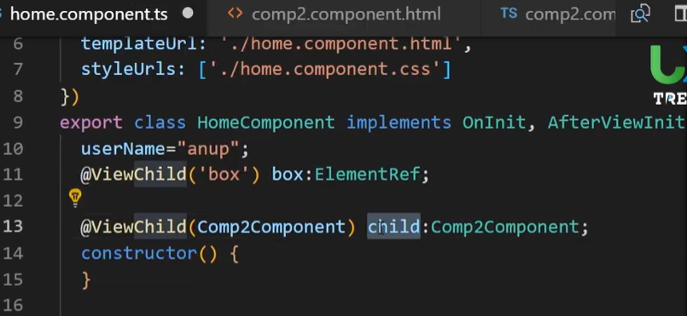

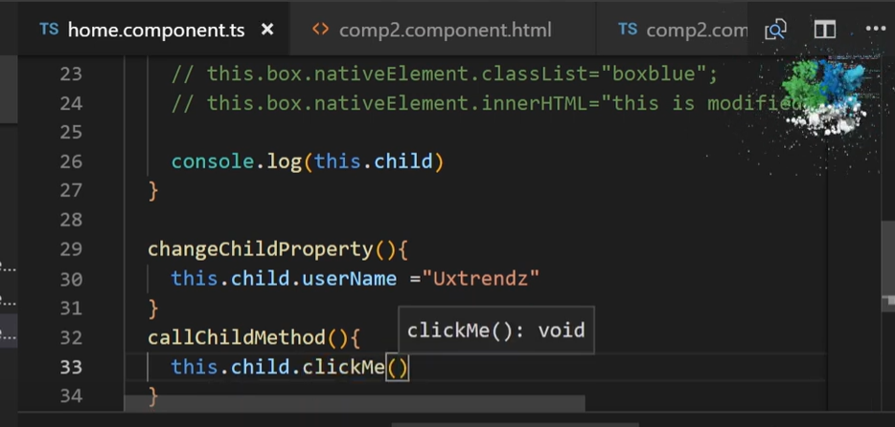

# Renderer 2 & Content Child

* Renderer is a angular class which is use as a service in angular

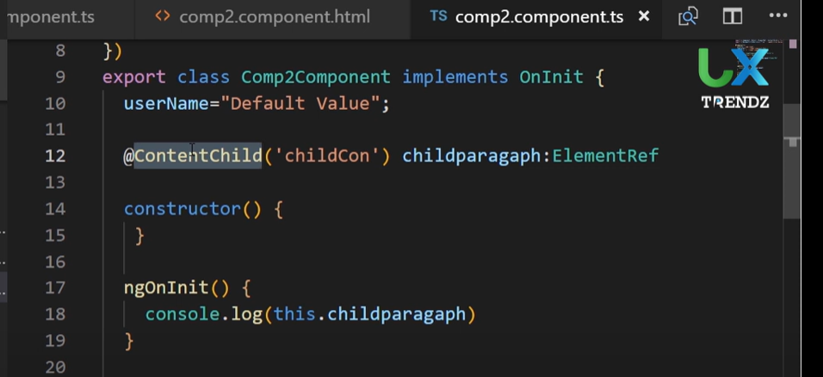

* To access the content of child component we @ContentChild.

# ViewChild with Directive

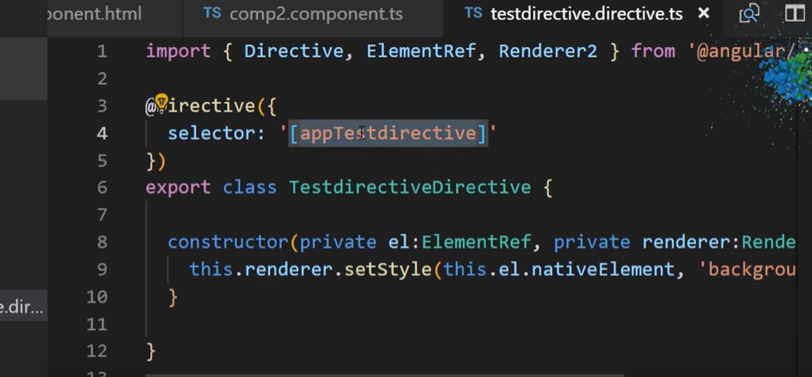

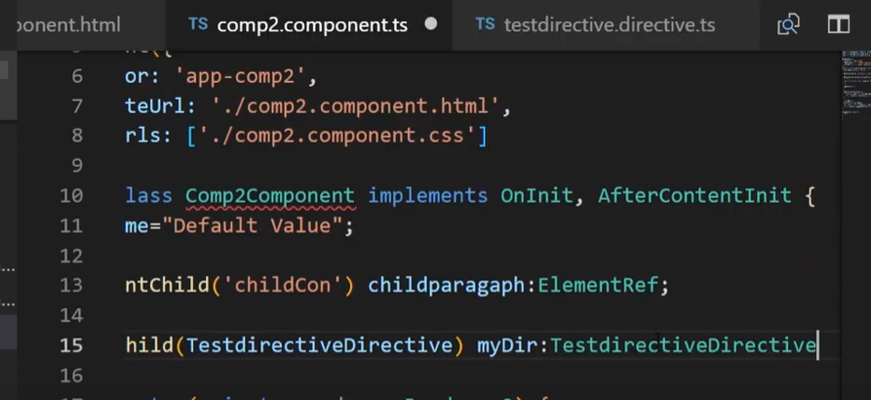

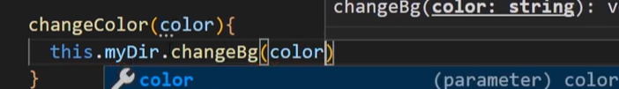

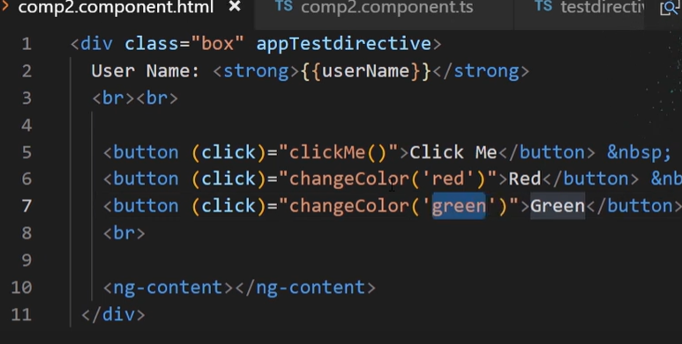

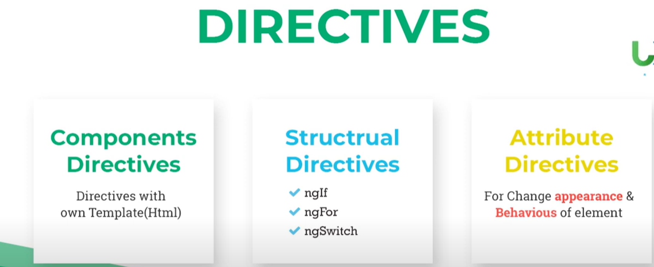

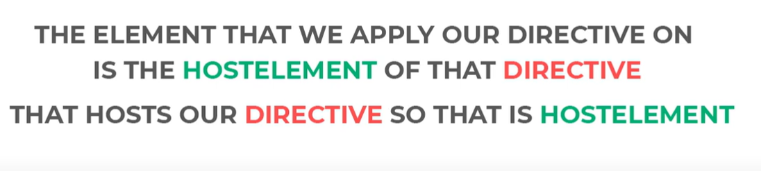

# HostListener

* If we want to acess the event of host element then we use hostListner

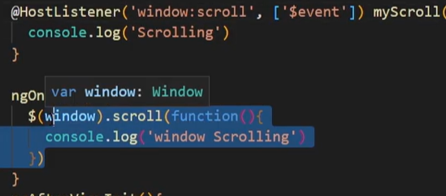

Hostlistener myscrolling function mentioned in screenshot will show the message in only host element component but window scroll function will call in every component.

# HostBinding

# Pure and Impure Pipes

Pure Pipe: Whenever pure change detects in pipe input value then it executes.

Impure Pipes: Whenever change detect in angular app then it executes. It slows the execution

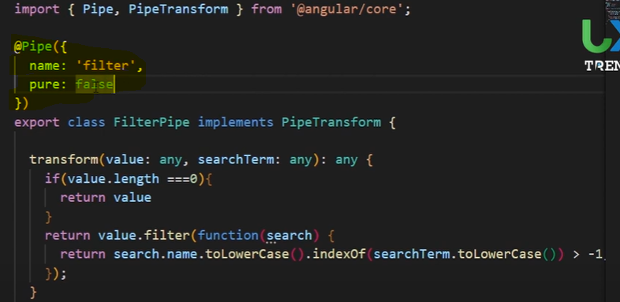

* By default pure pipe work, If we want to user impure pipe then we use pure:false

# Status & Value Change

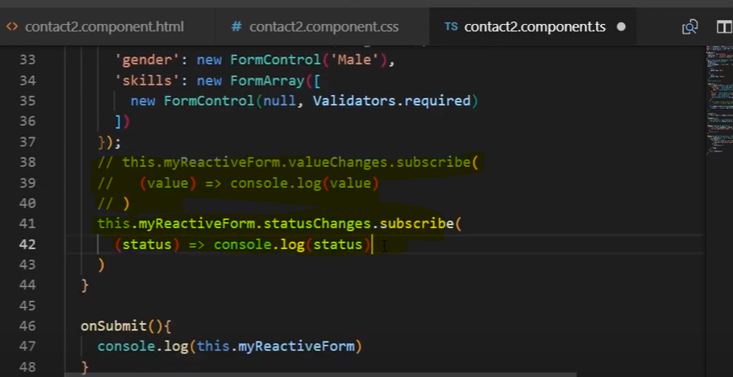

# Shared Module in Angular

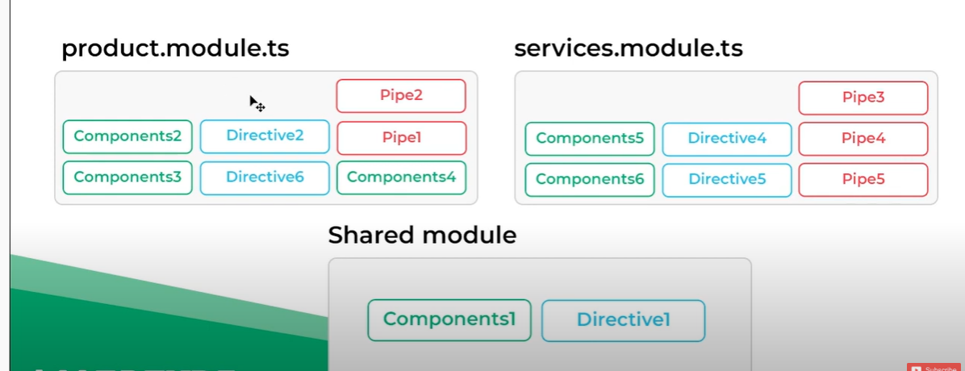

# Module Loading Strategy

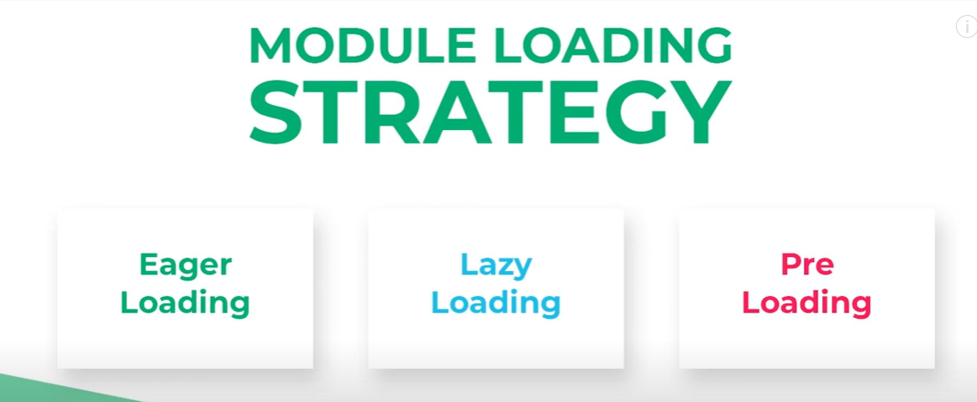

# Data Binding

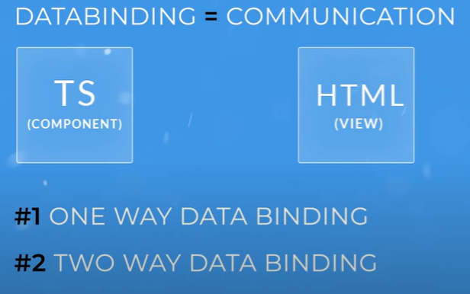

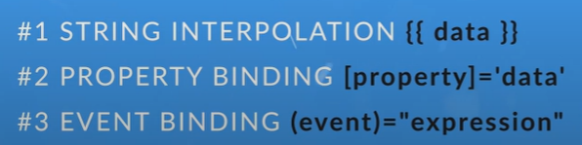

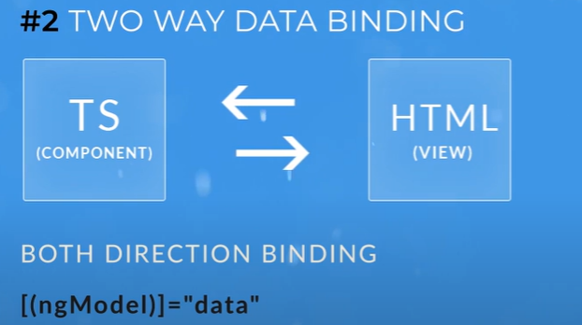

ng generate component --skip-tests=true databind

* String concatenation is not possible in property binding

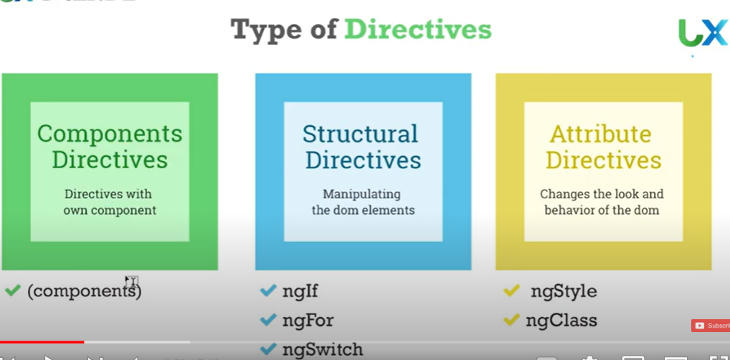

Directive is angular instruction , that change doc behaviour and apperance

https://www.youtube.com/watch?v=AfvWsVhlfIw&list=PLLhsXdvz0qjJHtgs1b7nyue6GDcSXfJNA&index=2

<https://www.youtube.com/watch?v=F1GUjHPpCLA>

es6

<https://www.youtube.com/watch?v=JTcjSvFptEM&list=PLwGdqUZWnOp19VX-DM4oHtmWhDfWblFh->